Practical 8
Using Flame Sensor and glow and LED

To interface a Flame Sensor module with Raspberry Pi 3 and detect fire/flame. When flame is detected, turn LED/Buzzer ON and display a message on the terminal.

Flame Sensor: -
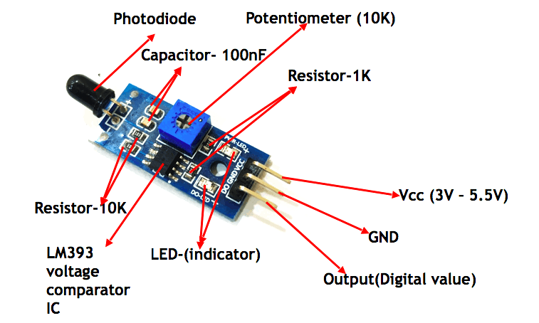

Definition
A flame sensor is a device used to detect the presence of a flame or fire by sensing light, heat, or ionized gases produced by combustion. It converts this detection into an electrical signal that can be used for monitoring, control, or safety systems.

Types of Flame Sensors
1. Ultraviolet (UV) Flame Sensor
- Detects ultraviolet radiation emitted by flames
- Very fast response time
- Common in industrial burners and gas turbines
- Limitation: Can be affected by UV sources like welding

2. Infrared (IR) Flame Sensor
- Detects infrared radiation (heat) from flames
- Works well for hydrocarbon fires (oil, gas)
- Slower than UV but more stable

3. UV/IR Flame Sensor
- Combines UV and IR detection
- Reduces false alarms
- Used in high-risk industrial environments

4. Ionization Flame Sensor
- Detects electrical conductivity of flame gases
- Common in gas stoves and boilers
- Simple and low cost

5. Photodiode / LDR Flame Sensor
- Detects visible light from flames
- Used in small electronic projects and robotics
- Not reliable for industrial safety

Uses of Flame Sensors
- Fire detection systems
- Industrial safety in furnaces, boilers, and burners
- Gas stoves and ovens (to ensure flame is present)
- Robotics (fire-fighting robots)
- Automatic fire alarms and suppression systems
- Power plants and refineries

Components Required: -
- Raspberry Pi 3 + SD card + power
- Flame Sensor module (commonly KY-026 / IR flame sensor)
- LED + 330Ω resistor (or Buzzer)\
- Breadboard + Jumper wires

Pin Connections: -

Flame Sensor | Raspberry Pi | GPIO Numbering
VCC (+) | Pin 1 | 3.3V
GND | Pin 6 | Ground
DO / AO | Pin 11 | GPIO17

Pin Connection :-
| Flame Sensor | Raspberry Pi | GPIO Numbering |
|--------------|--------------|----------------|
| VCC (+) | Pin 1 | 3.3V |
| GND | Pin 6 | Ground |
| DO / AO | Pin 11 | GPIO 17 |

LED / BUZZER: -

LED / Buzzer | Raspberry Pi | GPIO Numbering
- long Leg / + terminal | Pin 12 | GPIO 18
- Short leg / - terminal | Pin 14 | Ground

| LED / Buzzer | Raspberry Pi | GPIO Numbering |
|----------------------------|--------------|----------------|
| Long Leg / + Terminal | Pin 12 | GPIO 18 |
| Short Leg / - Terminal | Pin 14 | Ground |
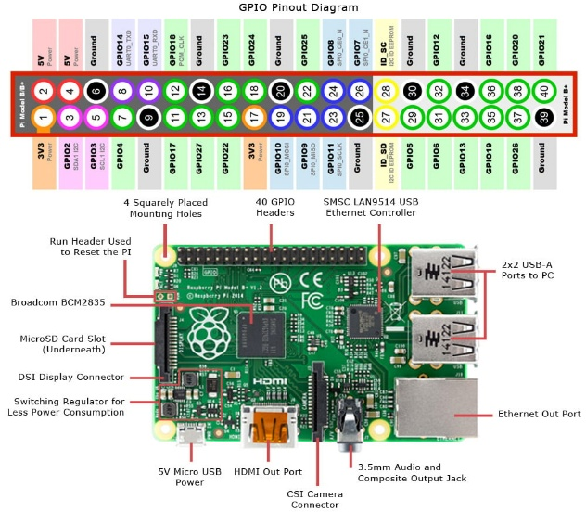
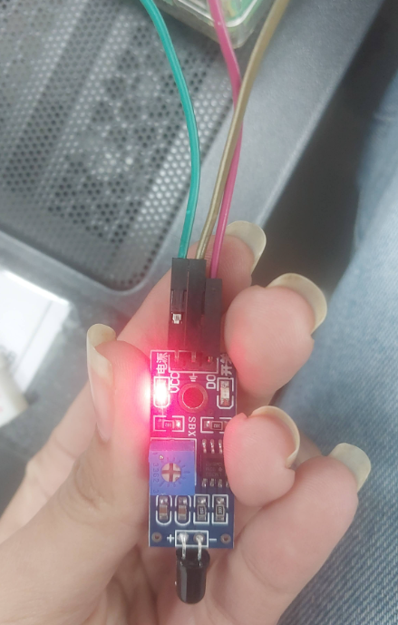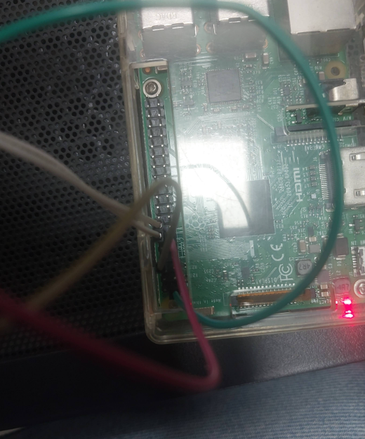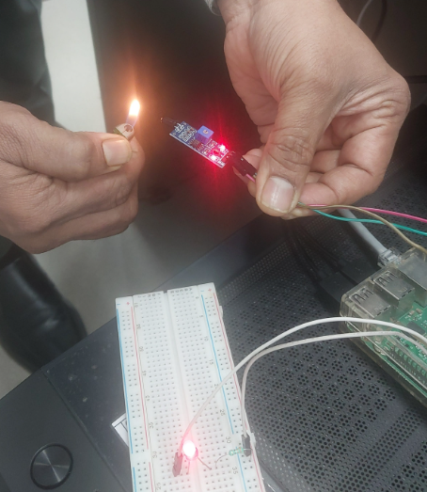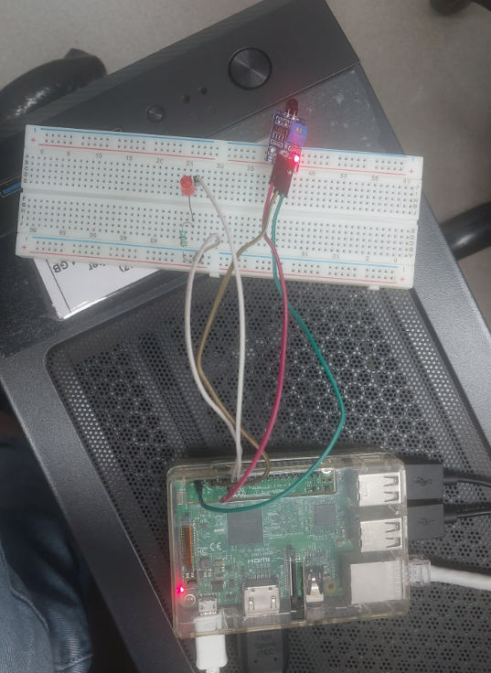

Code: -
"""
To interface a Flame Sensor module with Raspberry Pi 3 and detect fire/flame.
When flame is detected, turn LED/Buzzer ON and display a message on the terminal.
"""

import RPi.GPIO as GPIO
import time

# GPIO pin definitions
FLAME_DO = 17 # GPIO17 (Pin 11) - Flame Sensor Digital Output
ALERT = 18 # GPIO18 (Pin 12) - LED/Buzzer

# GPIO setup
GPIO.setmode(GPIO.BCM)
GPIO.setup(FLAME_DO, GPIO.IN)
GPIO.setup(ALERT, GPIO.OUT)

GPIO.output(ALERT, False)

print("Flame Sensor Ready... (Press CTRL+C to stop)")

try:
while True:
value = GPIO.input(FLAME_DO)
print("Sensor Output (DO) =", value)

# Many flame sensors are ACTIVE-LOW
if value == 0:
GPIO.output(ALERT, True)
print("Flame Detected! ALERT ON")
else:
GPIO.output(ALERT, False)
print("No flame detected. ALERT OFF")

time.sleep(0.5)

except KeyboardInterrupt:
print("\nExiting program...")

finally:
GPIO.cleanup()

Output: -
